**Big Mountain Resort**

*A look into increasing profit margins by justifying an increase in ticket price*

After getting an overview of the data; and sorting resort by states and other features; a heatmap was created to quickly see the correlation between the different features explored in the data. However the most important feature is average ticket prices; therefore this relationship was explored in the figure below:

We can note some high correlations such as vertical drop, fast quads, total chairs and runs. Based on these observations we can conclude

1. Ticket price could climb with the number of resorts serving a population because it indicates a popular area for skiing with plenty of demand..
2. The lower ticket price when fewer resorts serve a population may similarly be because it's a less popular state for skiing.
3. The high price for some resorts when resorts are rare (relative to the population size) may indicate areas where a small number of resorts can benefit from a monopoly effect.

After inserting all the missing values with the mean, we created a **linear regression** model and a **random forest model**. To predict the best price for the average adult we inserted the data frame into a pipeline; and through cross-validation found a model that gives the most accurate result.: the Random Forest Model. In the figure below we can see the most dominant features: fast quads, runs, vertical drop, and snow making area.

By using this model, we saw that Big Mountain Resort modelled price is **$95.87, with the actual price being $81.00.** Even with an expected mean absolute error of 10.39, there is room for an increase. This suggests that the resort is undercharging. By graphing the various features we can see how Big Mountain Resort compares to other resorts. The graphs below show this:

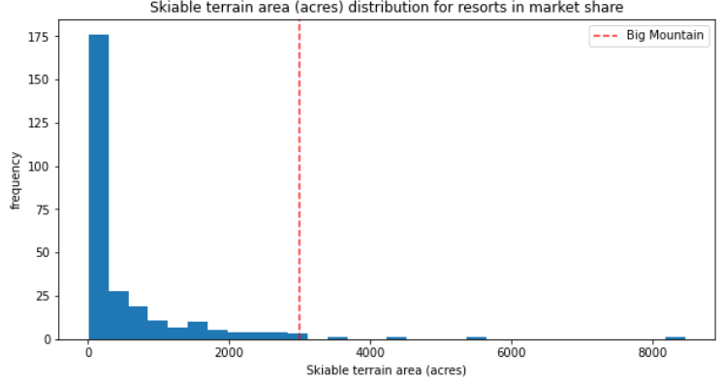

After careful consideration, 3 different scenarios’ were considered to justify increasing the adult ticket price:

1. Permanently closing down up to 10 of the least used runs.
2. Increasing the vertical drop by either (a) adding a run to a point 150 feet lower or (b) adding 2 acres of additional snow
3. Increasing the longest Run by 0.2 miles

**Scenario 1** - After changing these models to reflect these scenarios; a SCATTER PLOT was created to reflect the revenue loss if several runs were to be closed.

* If more than 6 runs were closed it led to a significant price drop (1.25)

**Scenario 2 -**  showed that adding a run, increasing the vertical drop and adding a chair lift would support a price increase of 2 dollars; nearly 3.5 million dollars of additional revenue. By modelling the second pat (2 acres); it shows that it would have a negligible difference.

**Scenario 3 -** showed that if an additional 0.2 miles was added to the longest run; it would make no difference whatsoever.

However there are still some things to take into consideration. It’s especially interesting to note that Big Mountain Resort already has the highest adult weekend ticket price in Montana. This mismatch would not come as a surprise to executives if Big Mountain State is considered one if not the best ski resort in Montana: Therefore it’s important to compare features to not only other resorts; but to investigate resorts specifically in Montana.

The random forest model created allowed us to model various scenarios that support an increase in price. Furthermore by using the data we have about number of guests visiting the resort; we can justify making improvements to the resort as we can model the revenue we expect to receive from these projects.